Rule assistant XML specification with examples

This doc has the Figma mock-ups, but the UI tool is working now.

|  |  |  |
| --- | --- | --- |
| **Element** | **Child Elements** | **Attributes** |
| FLExTransRule | source, target | name, create_permutations (yes, no) |
| source | phrase |  |
| target | phrase |  |
| phrase | word (1 or more) | type (src or tgt) |
| word | features (0 or 1), affixes (0 or 1) | id (integer), category (from FLEx), head (yes or no) |
| features | feature (1 or more) |  |
| feature |  | match (greek letter), label (from FLEx) |
| affixes | affix (1 or more) |  |
| affix | features (exactly 1) | type (prefix or suffix) |

# Determiner and Noun

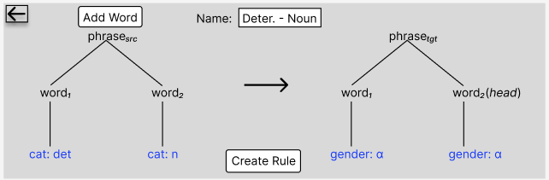

2 words, gender of target word 1 matches gender of head word

rule (name=Deter. - Noun)

phrase (type=src)

word (id=1, gramcat=det)

word (id=2, gramcat=n)

phrase (type=tgt)

word (id=1, head=no)

features

feature (match=α, name=gender)

word (id=2, head=yes)

features

feature (match=α, name=gender)

# Adjective and Noun

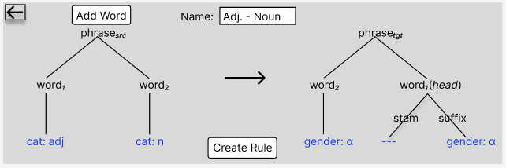

(in diagram, *head* should be on word 2)

2 words, gender of the suffix on word 1 matches the gender of the head word (word 2)

rule (name=Adj. - Noun)

phrase (type=src)

word (id=1, gramcat=adj)

word (id=2, gramcat=n)

phrase (type=tgt)

word (id=2, head=yes)

features

feature (match=α, name=gender)

word (id=1, head=no)

features {none in this case}

affixes

affix (type=suffix)

features

feature (match=α, name=gender)

# Adjective and Noun (2 feature agreements)

2 words, gender of the suffix on word 1 matches the gender of the head word (word 2) and the number of the suffix on word 1 matches the number of the head word (word 2)

rule (name=Deter. - Noun)

phrase (type=src)

word (id=1, gramcat=adj)

word (id=2, gramcat=n)

phrase (type=tgt)

word (id=2, head=yes)

affixes

affix (type=suffix)

features

feature (match= β, name=number)

features

feature (match=α, name=gender)

word (id=1, head=no)

features {none in this case}

affixes

affix (type=suffix)

features

feature (match=α, name=gender)

affix (type=suffix)

features

feature (match= β, name=number)

# Determiner, Adjective and Noun

3 words, word 1 matches in gender and number with the head word (word 3) and word 2 matches in gender and number with the head word (word 3)

rule (name=Det-Adj-Noun)

phrase (type=src)

word (id=1, gramcat=det)

word (id=2, gramcat=adj)

word (id=3, gramcat=n)

phrase (type=tgt)

word (id=1, head=no)

features

feature (match=α, name=gender)

feature (match=β, name=number)

word (id=3, head=yes)

affixes

affix (type=suffix)

features

feature (match= β, name=number)

features

feature (match=α, name=gender)

word (id=2, head=no)

features {none}

affixes

affix (type=suffix)

features

feature (match=α, name=gender)

affix (type=suffix)

features

feature (match= β, name=number)